Economics in the online game Team Fortress 2

Team Fortress 2, by Valve Software, is an online multiplayer game. Released in 2007, what was once a purely casual game has morphed into a competitive eSport with multiple competitive leagues and worldwide tournaments. However, what’s more interesting than the game’s competitive scene is the virtual economy surrounding the game and the trade of in-game cosmetics and items. Stemming from a 2010 update adding in-game item trading, the virtual economy has grown to immense sizes, with hundreds of accompanying community-made websites for everything from item classified listings to economy information and prediction blogs, with professional investor Paul Manwaring estimating the TF2 economy at a minimum of $50 million and some individual items selling at over $10,000 apiece.
The TF2 economy, overall, has seen many smaller ups and downs, but so far, there has been a large and frequently varied amount of inflation until April or May 2015. Since then, the in-game economy has been more or less stable.
One of the primary features of the TF2 economy is that of the three currencies; Refined Metal, Keys, and Earbuds. Refined metal, commonly known as ref, is an in-game item that is constantly generated in the form of weapon drops. In TF2, there are hundreds of weapons that you need to “find,” i.e. a system where one receives a random weapon or low-value item every hour or so of playtime for the first 12 hours, known as the “Drop system” (Fig. 1). TF2 allows players to “craft” weapons together for other weapons or for Scrap Metal, just referred to as scrap. Two weapons that belong to the same character (out of the 9 in the game) can be crafted into one scrap. Three scrap can be crafted into Reclaimed Metal, or rec. Three rec can be crafted into one ref. So, 18 weapon drops result in one ref, roughly translating to 18 hours of playtime. Ref is the lowest denomination widely-used currency in the TF2 world (scrap and rec can be used for extremely low-level trades, but with rec being worth a little over a cent, such trades can be ignored).
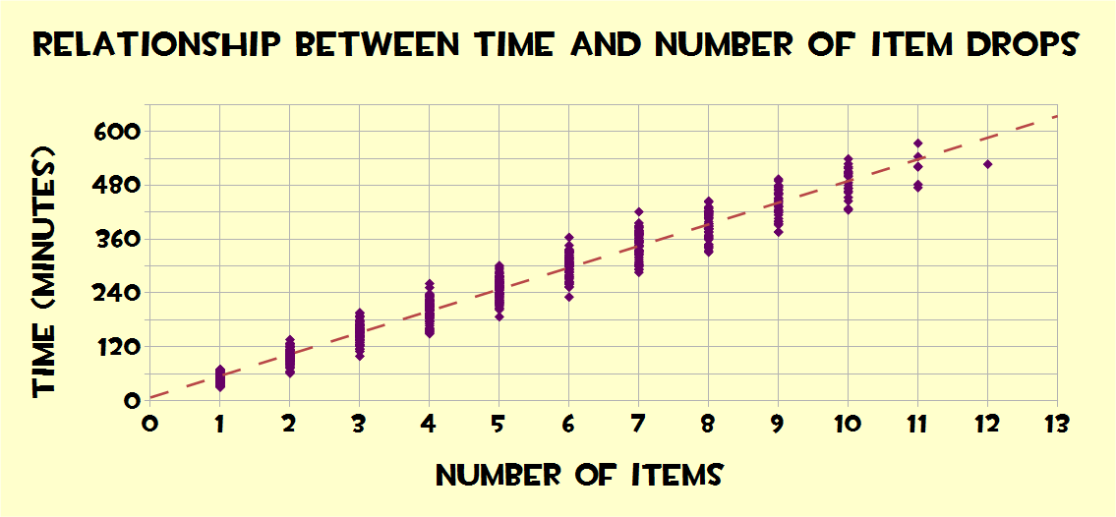
Fig. 1: Item drop rates
Keys and Earbuds are a different story, however. The only source of keys is from the official (Valve-run) TF2 store, where they are available for $2.50 each. Additionally dropping in-game in TF2 are “Mann Co. Supply Crates,” relatively worthless boxes that can be combined with a key (destroying said key) to “uncrate,” which drops a random item ranging anywhere from a $0.50 item to a $10,000 hat. However, keys on their own are much more valuable, and it’s unlikely that one will make any money or even regain their original $2.50 in item values after uncrating. The final currency in TF2 is the Earbud, or bud. These are comparatively the most valuable currency, and a result of the 2010 Mac Update, where TF2 gained Mac OSX support, and anybody who connected via a Mac over a week or so would receive a bud, a nod to the signature iPod and iPhone earbuds. As the update was a one-time event, the supply of earbuds is completely fixed (post-update) at an estimated 80,000 to 110,000 existing.
Now, moving to the commodity part of the tf2 market. One of the biggest aspects of TF2 trading are hats — literal hats. They don’t give any gameplay advantages or any sort of modifier augmentation; they’re literally just hats. Despite this, the demand for in-game hats is huge. Of course, there are hundreds of different hats, with the cheapest ones hovering at around 1.33 ref (about $0.15 at the moment), and the most expensive — generally Unusual hats; i.e. those with a special, flashy particle effect — ranging anywhere from 10 keys ($25) to $10,000 USD. The demand for Unusual hats is almost always high and inelastic; there are thousands of people whose sole goal in trading is to make it up to a point where they have the net worth to purchase an Unusual.
One of the hallmarks of the TF2 economy has (sadly) been its past instability. And it’s frankly easy to see why. Looking at a graph of the price of buds in USD, using the trading ratio to keys to determine USD price (Fig. 2, Backpack.tf). We can see that from Jan ‘13 to the current day, (Backpack.tf, the source of this data, only started tracking prices in Jan ‘13) the price has rapidly dropped until about May or April 2015. Starting out at roughly $60/bud in January (24 buds/key), the price rapidly dropped until the earbud was only about $6 (5 buds per 2 keys). Looking at the graph of the price of ref in USD — once again using the ref:key conversion factor — (Fig. 3), the price dropped from about $0.40 in Jan ‘13 (6 ref 1 rec per key) to just over $0.10 in the current trading market (25 ref per keys). This is pretty obviously a huge gap. But why would it happen? The answer’s relatively simple, and involves the money supply and currency demands in TF2.
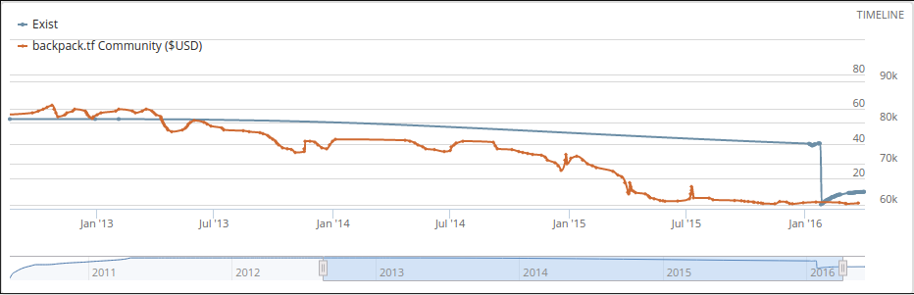
Fig. 2: Price of Buds in USD along with Estimated Number Existing
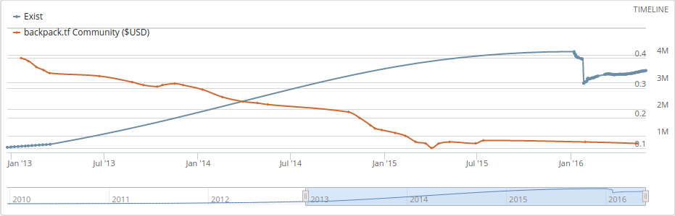
Fig. 3: Price of Ref in USD along with Estimated Number Existing
First, we have to assume that ref (and rec and scrap) are inferior goods (inferior currencies) in relation to keys, and keys are normal goods in relation to buds, but that buds must first be traded to keys in order to convert to ref or sell for real-world money. This is evident by the fact that ref is almost always used to complete low-level trades; those that people would preferably avoid due to their triviality. Meanwhile, all high-level trades are done in buds or keys, with the latter becoming more and more common due to the instability of the bud. Looking at the graph of the exchange rate of ref in relation to keys (Fig 4), we can see that the gradual influx of new ref without any sort of check or outflow possible (there’s really nothing productive to make out of ref, the only reasonable options are to trade for hats and keys) grossly increased the supply of ref, driving down its price against the key. And, our data matches with Fig 3, where it illustrates the dropping price of ref until Spring 2015. But what does this mean for the denizens of the TF2 economy? Well, for one, it makes it much more difficult for traders to work their way up to owning keys and higher-tier hats and unusuals, overall widening the inequality in TF2. Where once it only took roughly 36 hours of playtime to make $2.50 of in-game currency, it now takes over 300.
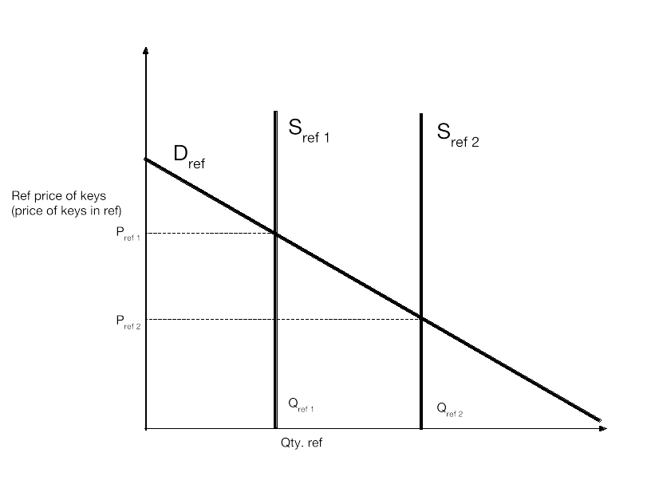
Fig 4: Price of Ref to Key
Now, for the market for buds. Buds are interesting in the fact that they’re much more of a commodity than keys or ref, but their supply is also completely fixed. So the reason of them dropping in price is almost entirely demand-side and has to do with TF2’s system of unusual hat dropping. Every time you open an in-game Mann Co. Supply Crate with an in-game key ($2.50), there is roughly a 1% chance that an unusual hat will drop. Being a form of gambling, many people are attracted and uncrate many crates, hoping for a high-tier unusual (one with a particle effect deemed rarer or better looking). However, new unusuals are released every few months. Another odd aspect of the unusual economy is that people usually want “pure,” meaning pure currency (e.g. buds, keys) for higher tier or more desirable unusuals, but you can commonly find those willing to accept “impure,” meaning other hats and items for less desirable or expensive unusuals. As such, the bud would appreciate in value every time a new unusual series or effect is released, then slowly depreciates as the novelty wears off. Combining this fluctuation in price with the fact that fewer people are willing to amass enough metal and keys to purchase buds creates a gradual depreciation over time, amplified by the fact that they’re almost a pure commodity with nothing holding them up in value other than the limited supply. Finally, Valve enabled buds to be sold on the Steam Community Market, where you can list and buy items for real-world money. Enabling buds to be sold for USD accelerated the move to equilibrium and created more or less a lowest-bidding war as people continuously undercut each other gradually into equilibrium, with high-level TF2 trader “JRatt” saying “When limited items [buds] were allowed to be sold on the market, buds were being bought and sold pretty rapidly since it was so easy.”
Another perspective on the decline was simply one of convenience. One trader, “Jigron,” says that it was that “there wasn't really a reason to have two forms of pure, and keys just made more sense.” Possibly the most well-known and accomplished trader, Bobsplosion, with an in-game backpack of over $100,000, says that “...the steam [game hub] trading window was limited in size… [the earbud] was used to mitigate the restriction… what I think killed it was the loss of its original purpose… we can now send thousands of keys at a time.”
Finally, as keys became more and more expensive in terms of ref, the demand for buds went down, as fewer people were able to afford the keys to purchase said buds. Bobsplosion also said that “...the issue was constant undercutting and people hoarding them,” contributing to instability. As such, many people remember the drop and fluctuations, viewing it as an unstable currency, and use keys instead. As well, the demand for keys overall has been rising, as they’ve been given more utility (more possible uses in-game) over time.
Overall, we can look at the TF2 economy as a model of small-scale macro communities. Plagued with constant inflation and general instability, it’s an interesting microcosm to look at, and can teach us a lot about the mentality of inexperienced buyers and sellers, with casual players able to individually affect the in-game economy.

"Competitive Play." - Official TF2 Wiki. Web. 01 June 2016.
"Item Drop System." - Official TF2 Wiki. Web. 01 June 2016.
I didn’t take a screenshot at the time so the chat logs other than this part are lost
Chat Log. Digital image. Steampowered.com. 31 May 2016. Web. 31 May 2016. <http://i.imgur.com/Ki1c3vr.png>.
Chat Log. Digital image. Steampowered.com 31 May 2016. Web. 31 May 2016. <http://i.imgur.com/Qzz6KYs.png>.

